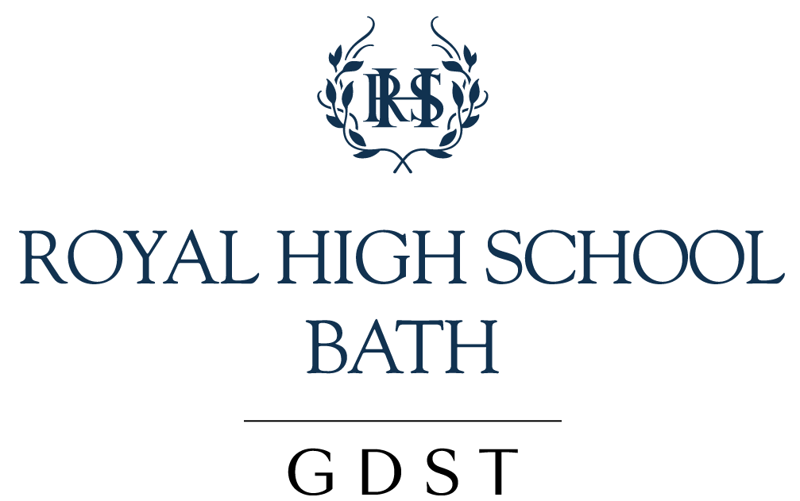

CAREERS EDUCATION AND GUIDANCE [LOUISE SCOTT] 2020-21

Anything which runs counter to the need of Social Distancing will be set aside during the time of the Covid-19 Crisis. The school will provide the best possible CEG in the circumstances.

Applicable to: All staff, students and parents.

Aims and Purpose of CEG:

- To develop positive attitudes and open-mindedness in the students, enhancing their personal and social development towards a fulfilling career path.
- To prepare each student for adult life and work by focusing on employability and adaptability.
- To enable each student to succeed according to ability by making appropriate choices of courses and subjects at key points of transition.
- To prepare each student for the Further or Higher Education course of their choice, or an alternative career pathway and to provide careers guidance, understanding and experience of work.
- To enhance the partnership between the school, parents, local businesses and the community.
- To enable parents to participate in important decisions about their children’s education.

Implementation:

There is a Head of Careers [Mrs Louise Scott] who ensures that students receive a programme of C.E.G. from Year 7 to Year 12.

- Careers Education and Guidance is based on the following principles:

- Impartial and confidential advice to students.

- Encouragement and opportunities for students to gain insight to and experience of a wide variety of careers. This can be delivered, for example, through the visits of guest speakers, access to Insight Days and Open Days, and access to the GDST’s Rungway mentoring platform.

- Opportunities to identify, reflect on and develop employability skills such as problem-solving, communication, self-management, teamwork, networking and creativity, both within and beyond the curriculum.

- The Head of Careers is available for consultation at lunchtimes and at other times by appointment.

- There is no Careers Library because most resources are available on online.

- There is a Careers Office within the Sixth Form Centre.

- Some of the Careers’ programme is delivered through PSHEE and comprises the following:

- Y7: employability

- Y8: employability continued

- Y9: adaptability

- Y11: creation of CVs and letter writing

- Psychometric testing via a career profiling platform is offered to all Year 10 students. Y10 students all have an interview with a school governor or a volunteer from the parent body.

- Students in Year 11 undertake a personality profiling exercise which identifies their strengths and weaknesses, and their preferred working style.

- Students in Years 11 and 12 are encouraged to undertake Work Experience. The Head of Careers gives advice.

- All have a Careers’ Guidance interview in Year 12.

- We run ‘Women Mean Business’ workshops for years 12/13 in the PSHEE system. This happens in alternate years.

- We run for Y12 networking with local businesses (using BBWA – Bath Business Women’s Association).

- The Head of Careers disseminates relevant information about careers electronically to the students and publishes it on the Firefly portal where appropriate.

Reviewed: September 2020 | Next Review: June 2021

