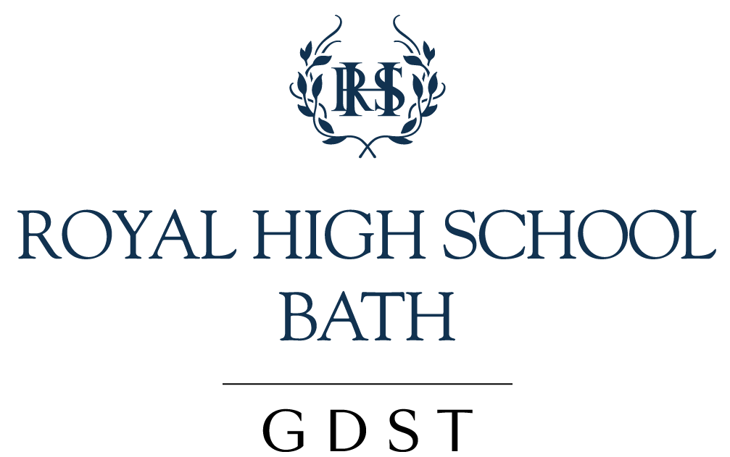

CURRICULUM [HADRIAN BRIGGS] 2020-21

The intention during the Covid-19 Crisis is to deliver a full curriculum through GHL and/or Blended Learning so that children in school, at home or in isolation are able to have equal access.

Applicable to: All students and parents and staff.

Preamble:

Our curriculum is key in securing the School’s Aims, and in particularly in ensuring that our pupils are encouraged to aim high, and become well rounded and successful individuals. We aim to do this particularly by focusing on identified Learner Habits (also known as the 6C’s.) These (in conjunction with the IB Learner Profile for the students taking the IB Diploma) provide an ideal for teachers and students to measure their learning activities against and as a tool for reflections on progress.

At the Royal High School Bath, the curriculum is designed to provide our learners with a secure basis for academic progress at each stage of their development. By providing a broad range of subjects we encourage students to develop a holistic understanding of the world while also encouraging depth learning. At each Key Stage the students are given more scope to specialise according to their interests and aptitudes through making subject choices.

In the Sixth Form we allow students two pathways and they have a free choice as to whether the A Level or IB route would best suit them. The IB Diploma demands that 6 subjects be taken across a range of disciplines, Higher Level subjects allow greater specialism than those studied at Standard Level. Our A level students choose 3 A level subjects from a free choice and also take an enrichment subject to ensure that there is some breadth to their choices. Both pathways encourage students to take a holistic approach to preparation for university including extended academic projects (an EPQ or Extended Essay) physical activity and sport (CAS, Core PE) and volunteering opportunities.

It is our intention that through their experience of our curriculum students will develop into committed and enthusiastic life-long learners.

You may wish to read more about the Royal High Learning Habits and the specific details of what is taught in each subject by following the links to our curriculum material below:

Royal High Learning Habits
Key Stage 3 Curriculum Booklet
Key Stage 4 Options Booklet
Sixth Form Options Booklet (IB and A Level)

Aims:

- To ensure that the curriculum for Years 7-13 meets the differentiated needs of all students, thereby creating a school environment which is academically stimulating. Please see the Gifted, Talented and Highly Motivated policy.

- To ensure that students at Key Stages 3-5 have a broad and balanced curriculum which enables them to pursue individual strengths and interests.

- To ensure that the curriculum includes access to information which will aid students’ personal development (through the PSHEE programme) and give unbiased access to information about the wide variety of careers that are open to them (through the careers programme).

- To ensure that the curriculum is relevant to the requirements of Higher Education selection and to the worlds of both work and leisure beyond school and education.

- To ensure that the curriculum is based on the structure and parameters of the National Curriculum and at KS5 [where appropriate] of the IB Programme.

- To include in suitable parts of the curriculum, as appropriate for the age of the students, material and learning opportunities which promote the fundamental British values of democracy, the rule of law, individual liberty, and mutual respect and tolerance of those with different faiths and beliefs.

- To include in suitable parts of the curriculum, as appropriate for the age of the students, materials and learning opportunities which promote respect for other people, paying particular regard to the protected characteristics as listed in the Equality Act 2010 (age, disability, gender reassignment, marriage and civil partnership, pregnancy and maternity, religion or belief, sex and sexual orientation).

Implementation:

- At the Royal High School Bath, Senior School we ensure that all students have an entitlement to the whole curriculum. It is an expectation that all lessons are planned so that all students are given the opportunity to achieve their best. This may involve differentiating lesson material to account for a specific learning need as identified by the SENDCo or offering additional support either in class, by assigning a Teaching Assistant, or through additional support sessions. Each department works to ensure that all their students are supported either through running additional lunchtime ‘help sessions’ or by making themselves available to students by appointment to help them improve. Those students with EAL are supported to access the curriculum by their teachers and are given additional support by the EAL Co-ordinator. All students are helped to develop their study skills throughout their time at the school. Sessions are planned for this in extended tutor time in Key Stage 3 and 4 and it is a focus of tutorials in the Sixth Form. Additionally sessions are run by external providers such as Elevate who help student prepare for GCSE study and examinations in Years 10 and 11.

- Each academic department is made up of qualified subject specialists who are recruited as they have a passion to share their subject with their pupils. Each Head of Department is responsible for ensuring that the agreed curriculum is delivered in their area. They meet regularly with the Deputy Head (Academic) to discuss curriculum matters and plan initiatives to ensure that the learning supports pupil development and achievement, including the Royal High School Learning Habits (6C’s). Departmental Handbooks, stored on the General Drive, contain schemes of work and further information about each department. There are regular meetings of the Heads of Department and those in charge of smaller areas within a large department. The meeting is chaired by the Deputy Head (Academic) and minutes are taken by the Assistant Head (Curriculum).

- The Deputy Head (Academic) is responsible for co-ordinating and timetabling the curriculum. He is assisted by the Assistant Head (Curriculum) and every effort is made to ensure that the curriculum choices provided at Key Stage 4 and 5 match with pupils’ interests and aspirations. The timetable is built so that the maximum number of pupils possible can study the option subjects of their choice, as well as core subjects of English Language, English Literature, Maths, Science and a Modern Foreign Language. In the 6th form the timetable is constructed around the choices made by students. Those wishing to take A Levels nominate their choice of subject for any 3 A Level and an Enrichment subject, those opting for the IB diploma choose 6 subjects from across 5 or 6 Curriculum areas.

- In addition to the curriculum delivered in lesson time the school is committed to providing exciting and dynamic opportunities for pupils to develop their learning and their interests beyond the class room. These activities are co-ordinated by the Assistant Head Co-Curricular and Well-Being.

- The school provides unbiased advice about the variety of careers paths that are open to the pupils. Opportunities to learn about these are woven into the PSHEE programme and managed by the Head of Careers. As a part of the GDST network of schools we are pleased to welcome alumnae in to talk to the girls about a wide variety of possible career choices.

- As part of the on-going School Development Planning, Heads of Department have an annual meeting with the Head and the Deputy Head (Academic) and may attend (with or without members of their department) meetings of the SLT. Curriculum, connected with teaching and learning strategies, is one strand which is examined. Departmental representations are then worked into departmental and whole school development plans.

- INSET is targeted so as to ensure all relevant staff are kept informed about curriculum changes at national level. Specific Teaching and Learning Priorities are identified annually and a programme of ‘CPD from Within’ is drawn up so that staff have opportunities to develop their practice so that student achievement can be supported by up-to-date and effective teaching and learning strategies. As a member of the GDST teachers from the school also attend Trust Office in London where nationally and internationally known experts in pedagogy deliver training to ensure the teaching and learning methods used to deliver our curriculum remains forward looking and effective. There are also ‘subject days’ at Trust Office where Heads of Department from across the trust schools meet together to discuss Curriculum Matters in their subject areas.

- Monitoring of the delivery of the curriculum is carried out through Classroom Observation, Staff Annual Review and Departmental Review. Departmental Reviews are on a rolling programme and include lesson observations, work scrutiny, student voice activities and review of results to measure how far students, including those identified as Gifted Talented and Highly Motivated, those with EAL, and those with identified learning needs are given opportunities to achieve and develop in line with their ability. Following the Departmental Review a report is written which commends the department on things which are going well and identifies areas for development.

- Heads of Department are responsible for ensuring that the Departmental Handbook is up-to-date. These handbooks include Schemes of Work, Programmes of Study, and departmental policies regarding teaching and learning and pupil achievement and development.

- Departments offer opportunities for students to study subjects over and above those in the core curriculum through lunch time and twilight sessions (e.g. GCSE Greek or Dance at Key Stage 4).

- Schemes of Work are highlighted to indicate opportunities that are taken to promote Fundamental British Values and allow these to be engaged with by the students.

- Alternative approaches to education are utilised in KS3 as a strategy to encourage the Royal High School Learning Habits and cross-curricular collaboration. For example, in the Festival of Ideas students go off-timetable and work around a theme in groups to work on a project. They are supported by teachers from different departments and speakers invited into the school.

Reviewed: September 2020 | Next Review: June 2021

