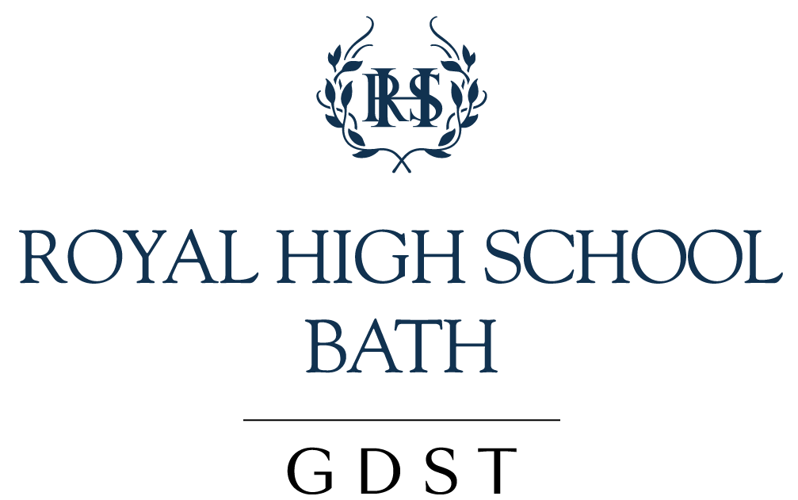
LANGUAGE [JUDE TAYLOR] 2020-21
Everything applies as stated during the Covid-19 Crisis.
Applies to: All parents, staff and students of the Senior School

1. Introduction and school context

The school language policy is to be understood within the unique socio-cultural context of the school. The Royal High School, Bath is an English school in an English setting, and throughout its existence, most of its students have been native English speakers from the locality. English is therefore both the operational language of the school, at all levels, and the designated language for all public areas.

Of the students who join the school from overseas, and who become part of the boarding community, most are sent here by parents whose strong desire is that their daughters become fluent in the language of the country, English. Their belief, generally, is that full immersion in English is an excellent method of achieving that goal, and they therefore expect the staff to communicate with their daughters in English.

The Language of Instruction throughout the school is English, the only exception, in the Senior School (Years 7-13), being Modern Foreign Languages, which are delivered through both English and the target language.

2. Aims

At The Royal High School Bath, our various language programmes aim to:
- enable students both to learn and to use language precisely, fluently, with confidence and with expressive power
- develop students’ powers of oral and written communication
- develop listening skills in students
- enable students to develop and use language skills in a variety of contexts and situations
- promote the understanding, analysis and appreciation of language in literature and of literature as a medium for representing ideas, cultures and times
- understand the vocabulary and terms used in different subject areas
- encourage students to discover the ways in which language conveys the varying perspectives of people of different cultures
3. Philosophy

At the Royal High School Bath, we believe that language is vital to both life and learning, and that language plays a part in what the school endeavours to develop and nurture in every student.

We understand that:
- Language is a key method by which we communicate and learn.
- Language is acquired throughout life and is essential to personal, intellectual and social development.
- Language is learned through use in interaction with others, both in speaking and writing.
- Language is best learned through immersion, both in the language and the culture of the language.
- Language should be valued as both an expression of culture and an integral part of a person’s identity.
- The development of language is essential for developing cognitive understanding and conceptual understanding.
- The development of one’s best language is critical for developing and maintaining cultural identity.
- The skills involved in learning a second language are transferable to other languages, and language proficiency aids learning and understanding in other curricular areas.
- The learning of another language aids understanding of the way in which others interpret and relate to their world and promotes international mindedness.
- Academic language is not the same as everyday language and needs to be taught.
- All teachers are teachers of language.
- Language learning should be fostered in all aspects of school life through a holistic, cross-curricular approach; this enhances the teaching and learning process, aids retention and stimulates interest in the fundamental values of communication.
- All teachers and house mistresses should seek to recognise the language needs of all students and work to serve those needs both inside and outside the classroom.

4. School Language Profile

At the Royal High School Bath, most of the students come from families where the language spoken at home is English and their education has been within the UK system where English is taught as a first language. Nevertheless, in any given year’s student population, we are likely to have students from 15 different nationalities, who speak 19 different best languages.

Most teaching staff also have English as their best language. There are, however, best language teachers of French, German, Spanish, Italian and Chinese origin, all working within the Modern Foreign Languages Department, and there are a number of other teachers (both of Modern Foreign Languages and other subjects) who are bi-lingual. Amongst support staff, there are best language speakers of Polish.

Implementation
5. Language provision

  - Teaching and learning of the host country language and culture - English

The aims of the English department are “to foster articulacy, confidence and distinction across the range of activities traditionally identified with the disciplines of English and English Literature”, to contribute to the academic success of our students and “to promote their personal development as reflective and independent individuals.” (English Department Handbook)

English is taught in mixed ability tutor groups or teaching sets from year 7 to year 11. This reflects a philosophy within the department that students of differing abilities can all learn from each other and stimulate each other in different ways within the interplay of ideas in the classroom. Extra support, both for those who are of lesser ability and for those whose best language is not English, is provided, as appropriate, in several classes each fortnight by the Teaching Assistants or by the EAL Coordinator.

The importance of English throughout the curriculum is never underestimated, as it is the language used in all subjects and for all examinations, and the staff in the department are aware of their responsibilities to provide a good grounding in oral and written skills for all of life, academic and beyond.

Many extra-curricular English activities are offered for the further enriching of students’ command and enjoyment of the English language: debating, Creative Writing Club, Model United Nations, English Speaking Union activities, Lit Lunch for the Sixth Form, creative writing opportunities in many and varied competitions locally and nationally, theatre trip for all ages.

  - The provision of English as an Additional Language (EAL) and of support for those not proficient in English

Applications to the school are welcomed from students for whom English is an Additional Language (EAL) or second language. Applicants are assessed for their suitability for entry at the different levels either through specifically targeted entrance examinations or, at Sixth Form level, by their adherence to the following requirements: an IELTS score of at least 6, or an equivalent qualification in IGCSE English Language. As far as is possible, all applicants also have a skype interview or come for an interview and/or taster day, during which attention is paid to their level of spoken English.

Information regarding students’ best language is gathered during the application process. It is stored in the school database and is accessible to all staff. Teachers are encouraged to make themselves aware of the different languages and nationalities represented within their individual subject classes and to develop lesson plans that emphasise differentiated instruction and that honour multicultural diversity.

EAL students study English and English Literature with best language English students within the mixed ability teaching sets. English teachers are aware of the EAL students in these classes and differentiate accordingly. In-class support is available from the EAL Coordinator and Teaching Assistants. All EAL students in Years 10 and 11 prepare and are entered for the IGCSE English and English Literature examinations.

Short stay EAL students are given the opportunity to do the Cambridge First Certificate Examination, or other suitable examination, so that they can return to their home country with a qualification in English. Sixth Form students who come into the school without GSCE English for their UCAS applications can sit the IELTS examination. Training for this is available and the examination can be sat at the local university.

Those studying the IB Diploma Programme gain a qualification in English as a best language, since all students study English A: Literature either at Higher or Standard Level. English as a Group 2 Language is not offered, because of insufficient numbers asking for it. (However, students with two languages are encouraged to take both English and their own best language in Group 1, thereby gaining a bi-lingual diploma.)

Overseas students are entitled to specific EAL tuition which is included in the fees: up to Year 11 at least one lesson per week and in Years 12/13 one lesson a fortnight. Places at the school are sometimes offered on the condition that the student attends additional Language Support lessons beyond those offered as part of the curriculum. These lessons may be delivered individually or in small groups. If the number of lessons exceeds those specified above, there is an additional charge.

An EAL Coordinator is available for all language teaching and support as required. In close communication with the Registrar, she draws up and maintains the EAL register, identifying which students need regular support; she keeps up a regular dialogue with tutors and subject teachers about EAL students; and she also provides support and training as necessary to the staff.

Teachers and non-teaching staff are all made aware of EAL students and encouraged to be supportive of their needs, academically and within the wider school environment. They can recommend or refer students to the EAL Coordinator at any point when they are concerned.

  - The support of and provision for learning best languages other than English

The school acknowledges the importance of recognising and developing each student’s best language. Assemblies and other school events are staged regularly to celebrate other languages and cultures.

Students can take examinations (GCSE and GCE) in their native language, as appropriate.

Within the IB Diploma Programme, arrangements are made for students to be taught the Group 1 Literature course at Higher Level in their best language, if there are enough numbers applying for it and a teacher of the language available. In the past, this has included German and Spanish. Currently it includes German and Mandarin.

Where a taught Higher-Level course is not possible, students are always offered the opportunity to study their best language as a School-supported Self-taught Language Standard Level. The IB Coordinator oversees delivery of this programme. In the past, Japanese, Chinese, Korean and Russian have been studied in this way. Chinese may be studied as a School-supported Self-taught best language.

  - The provision, teaching and learning of modern foreign languages (IB Group 2 Languages)

Modern Foreign Languages are strong within the school. The aim of the department is to foster a love of languages, to develop an awareness of the nature of language itself, and to provide a learning environment that will produce “positive, confident and competent linguists”. Teachers believe that for a student to learn a foreign language “means understanding and accepting that there are many equally valid ways of viewing the world and of expressing one’s feelings” and develops “positive attitudes towards speaker of other languages, their cultures and civilisations.” (Modern Foreign Languages Department Handbook)

In the Prep School French, German, Spanish and Mandarin are offered. In Year 7 all students study French, German and Spanish throughout the year. In Year 8, students study two of the three languages, but also take Mandarin as an enrichment course. In Year 9, all students study two out of the four languages, though students with learning needs may be permitted to take only one.

Virtually all students take one MFL at GCSE. Some students opt for two. There is also the possibility to study Italian in the extension block. This is a fast track course for able linguists.

Students who join the school late in Key Stage 3 are assessed carefully by the Head of Department, and, as far as possible, assimilated into the language curriculum. They are given guidance on whether, and how much, private coaching might be required for them to integrate into the courses. Overseas students at Key Stages 3 and 4 are able to study one MFL and use the remaining lessons for EAL learning. Foreign Language Leaders from Year 12 offer tutor sessions to students in KS3 and KS4 who need extra support or challenge.

Students who are semi-native speakers are given weekly lessons with the language assistants outside of the curriculum. They may then take GCSE or GCE examinations as appropriate.

In the Sixth Form, the languages currently on offer are French, German, Italian, Spanish and Mandarin at AS and A-level, and French B, German B, Mandarin B and Spanish B at Higher and Standard Level in Group 2 of the IB Diploma Programme.

All students in KS4 and KS5 have weekly conversation lessons with native speakers.

All students are offered the opportunity to take up Beginners’ Russian or Mandarin through a weekly lesson after school.
  - The provision, teaching and learning of classical languages

All students are given the opportunity to learn Latin from Year 6 onwards, beginning with the Foundation Course, Minimus, in Year 6. In Years 7 and 8 Latin is studied by all, but in Year 9, students may opt for Classical Civilisation in place of Latin.

In Year 9, Greek taster lessons are offered to those studying Latin.

Greek and Latin are both available from Year 10 onwards, at IGCSE, GCE Level and within Group 2 of the IB Diploma Programme.

6. Admissions and assessment policies

Applications into the school are welcomed from students who are EAL or bi-lingual, and the admissions process is outlined above, under 5.3.

Assessment at all levels considers whether a student is a best language speaker or not. In internal end-of-year summative assessments, vocabulary lists for some papers may be provided for EAL students. In external examinations, EAL students who regularly use a dictionary are permitted, in accordance with the individual exam board regulations, to take a bi-lingual dictionary into the exam.

7. Communication with non-English speaking parents and guardians

Most of the parents speak English either as a best language or second language, and all students from overseas have a guardian locally who is an English speaker. Reports and letters to parents are all written in English, and academic evenings are also conducted in English.

For parents who do not speak English and wish to attend parents’ evenings or individual meetings, the school arranges, as far as is possible, a person who speaks both English and the other language to interpret.

8. Professional Development

Teachers are all made aware of the needs of the EAL student and the bi-lingual student. The EAL Coordinator also requests and collates vocabulary lists from subject teachers, some of which are sent in advance of a student’s entry to the school, and she regularly communicates on a one-to-one basis about individual students. When required, she speaks at a full school staff meeting, reminding teachers of the needs and requirements of the EAL students in the school.

9. Language Policy Review and Action Plan

This Language Policy is reviewed by the IB Coordinator annually. The IB Coordinator liaises with the EAL Coordinator, Deputy Head (Curriculum) and Head of the Modern Languages Faculty.

Reviewed: September 2020 | Next review: June 2021

