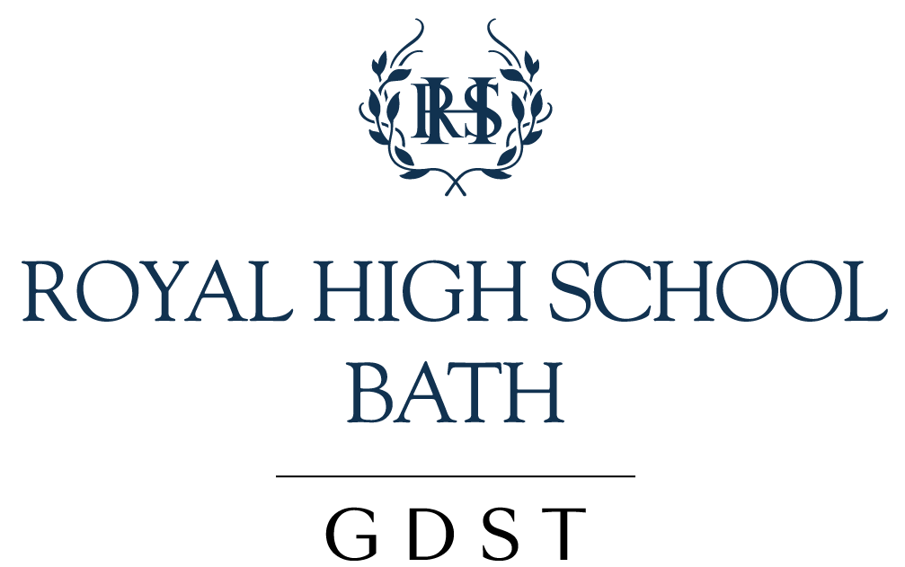

ADMISSION OF STUDENTS (PS&SS) [FRANCESCA ORR, CLAIRE LILLEY] 2020-21

Applicable to: All prospective students, parents and staff.

See also: Accessibility Policy, Equal Opportunities Policy, Learning Support (for EAL), Overseas Students Policy

Aims:

- To ensure that all sections of the school are open to girls who are judged to be capable of benefitting from the education provided and of contributing to the life of the school.
- To support the idea that girls admitted to the Prep School are very likely (if it is appropriate) to progress through the school, exploiting the benefits of right-through schooling.
- To ensure that academically able students who are likely to qualify for further education post-16 are selected for entry – both day and boarding – thereby creating an environment in which learning, intellectual enquiry and scholarship are valued.
- To ensure that the assessments that take place are age and experience appropriate.
- To ensure that students are offered places on the basis of achieving an acceptable standard in their assessment/examination.
- To make the offer without discriminating against any student or parent on the grounds of race, nationality, colour, ethnic/national origin, disability, sexual orientation/religion/belief (actual or perceived).
- To give due consideration to educational experience in assessing ‘acceptable standard’ and to maximise access for students to whom the RHSB can add value.
- To ensure fairness and transparency in the admissions process.
- To ensure we are in line with GDST Council’s Policy.

PLEASE NOTE: THIS POLICY SHOULD BE READ IN CONJUNCTION WITH THE POLICY ON OVERSEAS STUDENTS.
THE SECTION REFERRING TO THE NEW UKVI’S REGULATIONS IS OF VITAL IMPORTANCE.

The Nature and Range of the Ability of the Intake:

In line with all GDST schools, the policy of RHSB is to admit students on the basis of academic selection, with the exception of Nursery:

- At 3+ (Nursery) pupils are not formally assessed. Nursery pupils are assessed against the EYFS guidelines and transfer directly to Reception. These pupils are monitored throughout the Early Years Foundation Stage and Key Stage 1 to ensure that they are on target for Key Stage 2.
- At age 4 a pupil will be assessed by Nursery for half a day to ensure they are on track to achieve the EYFS goals at the end of Reception.
- From aged 5 to 10 (into Year 1 to Year 6) prospective pupils usually have a two-day assessment visit with their peers and follow the pattern of a normal school day. The Form Teacher is responsible for carrying out the assessment in English (NfER reading, comprehension and writing) and Mathematics. (This includes marking the tests, giving brief written comments and making a recommendation to the Head.) A reasoning test is also carried out when it is felt necessary.
- At 11+ (into Year 7) by examination in English, Mathematics and Verbal and Non Verbal Reasoning. Successful candidates will demonstrate that they are at a level equivalent to former NC Levels 4-5 in English and Mathematics. As the norm, the minimum Standardised Score for entry on Verbal Reasoning is 105. All external candidates are interviewed by the Head and the Head of Key Stage 3 in the week before the examinations. EAL students are asked to take a Non Verbal Reasoning test. Before the end of the Autumn Term the Head interviews all internal candidates.
- At age 12 (into Year 8) by examination in English and Mathematics. Candidates might be required to have an interview in person or by Skype.
- At ages 13 and 14 (into Year 9 and 10) by examination in English, Mathematics and Science. Successful applicants will demonstrate the potential to pass GCSEs at Grades A*-B (or equivalent) in a range of subjects. Consideration is given to background in Modern Languages. Candidates might be required to have an interview in person or by Skype.
- For students coming from the UK to study for either A Levels or the IB Diploma: At 16+ (into Year 12) on condition of passing at least six GCSEs at Grades 9 – 6 with the proviso that students must have a minimum of a grade 7 in the subjects to be taken at AS Level / IBDP Higher Level or in the subjects being used as criteria by subjects which are 'new' to 6th Form students. (A minimum grade 5 or equivalent in English and Mathematics is required.) Candidates might be required to have an interview in person or by Skype.
- Also at 16+ into the Sixth Form on condition of completing the IB Middle Years programme to a level equivalent to at least six GCSEs at grades 9- 6 with a minimum of a grade 5 in English and Mathematics. Students are usually ask to take entrance tests in specific subjects, as above.
- For students coming from overseas: At 16+ (into Year 12) applicants are considered for either the IB Diploma programme or A Levels on the basis of: predicted results at IGCSE or equivalent, an English GCSE-style entrance paper, a Mathematics GCSE-style entrance paper, and entrance papers in subjects proposed for sixth form study. There is an EAL examination for non-native speakers, although an IELTS score of at least 6 or an equivalent qualification such as grade 6 in IGCSE English Language is preferred for entry into the 6th Form. Where students are not in a UK school, any provisional offer made by the Head is confirmed upon verification of GCSE or IB Middle Years programme results in the August before entry, unless the student has had an unconditional offer based on her entrance examination results.

Implementation:

Prep School Admissions

- Invitation to come for assessment is to be made only after receipt of the Registration form and fee except in unusual circumstances.
- An offer may be made, subject to a satisfactory assessment and satisfactory report from the existing school, if required.
- Parent/carers are to be informed of the outcome of an assessment as soon as possible. In the Prep School this is the responsibility of the Head usually at the end of the day. A Deputy Head may be asked to speak to the parent/carers if the Head is not available.
- Offers to be sent out under the signature of the Head of the Senior School.
- Applicants who live far away from Bath or overseas may sit the Assessment tests in English and Mathematics at their own school under examination conditions or under the supervision of an appointed agency.

Key Stage Admissions in the Senior School

- Parents can obtain a copy of this policy and the GDST’s own policy on admissions from the Registrar in the main School Office; the admissions process is also explained on the RHSB website.
- Applications for registration and to take the entrance exam for a Trust school are made on the RHSB’s own application form.
- All students to be admitted on the basis of an appropriate entry/transfer examination and interviews. Students must achieve an acceptable standard in the examination. A report from the current school is obtained whenever possible.
- Interviews with parents do not form part of the selection procedure.
- Relevant Heads of Department have responsibility for setting, marking and reviewing entrance examinations appropriate to each stage of entry. Tests are reviewed annually.
- The entrance examination is not set to clash with any major religious festival.
- Parents to be informed of the outcome of entrance/transfer examinations as per the agreed timetable.
- Entrance/transfer examinations are taken in conditions which are both conducive to academic work and concentration, and which encourage applicants to relax.
- Individual needs are taken into consideration in consultation with feeder schools.
- Entrance/transfer examinations are to be supervised by the Registrar or her representative.
- Recommendations for offers or rejections, subject to performance in the entrance examination, are to be made by the relevant Heads of Department to the Head.
- Offers are to be sent out under the signature of the Head alone.
- Invitations to sit the Entrance/Transfer Examination are to be made only after receipt of Registration Form and Registration Fee.
- All students considering entry to the RHSB are offered a taster day or night (in the case of boarding). For Year 7 students a taster day is part of the admissions process.
- Overseas applicants are to sit Entrance Examination under the supervision of an appointed educational agent/British Council/their school with the agreement of the overseas Head or similar trustworthy body.
- All Year 7 entrants are invited to the induction afternoon in the Summer Term of Year 6.
- Reports are requested from current schools (where relevant) using RHSB standard form.
- No student can start unless her parents have signed and returned the parent contract (F7).
- Parents of unsuccessful candidates may ask for feedback from the Head about how the child performed in relation to the range of successful candidates and about how the selection criteria were objectively applied. (Exam scripts are not shown to parents, being exempt from disclosure under the Data Protection Act 1998.) Discussions with parents may be followed up in writing.
- There are exceptions to the normal selection criteria. The Head looks at individual cases where there are extenuating circumstances (e.g. if a student has been educated at home). The Head (or her nominated representative) interviews the student and makes a decision.
- The Prep School, Senior School and 6th Form take siblings (3 -18). Priority is given to siblings, subject to them satisfying all other entry requirements.

Inter-school Transfers

- Transfers between other GDST schools and RHSB may be arranged for reasons such as relocation or the need for boarding facilities or the desire to study the International Baccalaureate Diploma.
- A transfer cannot be made to any Academy sponsored by the GDST.
- Transfers are subject to place availability and the receiving school’s professional judgement re the benefit the student would get from joining.
- Pupils transferring from another Trust prep school are not required to pass the admissions assessments but may be asked to complete some of the tasks for diagnostic purposes. A written report covering the core subjects, any strengths or weaknesses with a comment on behaviour is the norm but, in unusual circumstances, a verbal report by the Head may be given.
- Admissions in Years 7 and 12-13 are as for anyone else. Mid-year admissions and admissions in Years 8-10 are by reference from the current school and a ‘grading’ entrance exam.
- The Head contacts the Head of the current school re the student’s ability and potential.
- When places are available, GDST policy requires priority to be given to students transferring from other GDST schools.

Post-16 Transfers

- Parents are informed of the RHSB’s standards for entry into the Sixth Form.
- After mock GCSE exams the Head sees any parent of a student about whom there is concern. This takes place before the end of the Year 11 Spring Term. The grades required for entry into the Sixth Form are set out in the standard notification letter.

Siblings

In both the Junior and Senior Schools a sibling discount is offered on the third or subsequent daughter/s to the value of 20%. This runs for the duration of the third daughter’s school career even when the two older girls have left.
SCHOLARSHIPS AND BURSARIES

Royal High School offers two types of financial assistance to students of exceptional ability and promise: Scholarships and Bursaries.

SCHOLARSHIPS: ACADEMIC and SPECIALIST
Scholarships are made, irrespective of parents’ financial situation at the entry points of Year 7 (11+) and Year 9 (13+) for external students and at entry/transfer into the Sixth Form in Year 12. These are awarded for all-round academic excellence and for outstanding promise in a specialist area.

Year 7 (11+) Scholarships:
Academic
Specialist Subjects: Art, Drama, Music (including Choral), Sport and Dance
Academic Scholarships are made to those who demonstrate exceptional intellectual potential in our Year 7 Entrance Assessments (English, Mathematics and Reasoning). Year 6 students from Royal High Prep School take the same papers as external students. Scholarships are open both to girls from Royal High Prep School and to those applying from other schools. Specialist awards are made to internal and/or external candidates who demonstrate outstanding ability in art, music, drama or sport. Decisions are made on the basis of an audition/practical or on the presentation of a portfolio of work.

Year 9 (13+) Scholarships (for external students only):
Academic: STEM (Mathematics, Science, Technology) and ARTS (English, Languages, Humanities)
Specialist Subjects: Art, Drama, Music (including Choral), Sport, Design Technology and Dance
Academic Scholarships are made to those who demonstrate exceptional intellectual potential in our Year 9/13+ Entrance Papers (English, Mathematics, Science & a language – French, Spanish, German or Latin). Candidates may be invited for a further assessment day of observed lessons. Specialist Awards are be made on the basis of an audition/practical and are available to new entrants to the school at Year 9/13+ only. Scholarships will be offered by the end of the Spring Term.

Year 12 Sixth Form Scholarships:
Academic: 2 exams in either STEM (Mathematics, Science, Technology) or ARTS (English, Languages, Humanities)
Academic: The IB (International Baccalaureate) Scholarship: 3 exams in a combination of Arts/Science
Specialist Subjects: Art, Drama, Music (including Choral), Sport (including dance), Design Technology
A personal statement is also required with the application.

Academic Scholarships are usually worth up to 15% of a scholar’s day fees. Awards are granted solely on merit as the result of a competitive assessment process. Applicants who are likely to require a larger fee reduction should also apply for a means-tested bursary prior to the entrance examination. Applicants may apply for any combination of Academic and Specialist Scholarships available to her year group. Specialist Scholarships are usually worth up to 10% of day fees.

All awards are retained to the end of Sixth Form and are reviewed at regular intervals. Ongoing commitment to an individual’s area of specialism is a requirement of the continuation of a Specialist Scholarship. Scholarships can be withdrawn.

Guidelines for Specialist Scholarship Applications

Art: An award for art is unlikely to be made unless the applicant can provide evidence of sustained, independent and varied work of an exceptional standard. Candidates may be expected to discuss their work with members of the Art Department.

Design Technology: It is expected that a Design and Technology Scholar will be taking the subject for GCSE, on course to achieve a grade 9. Candidates must have a keen interest in design and demonstrate this interest both inside and outside of the curriculum. Students should show their commitment to pursue a technological degree course in a subject such as Engineering, Product Design or Architecture. A further facilitating A-Level subject in either science or Maths would be preferred. At interview candidates will be asked to bring a sample of work or GCSE coursework and be willing to talk through their design concepts with the Head of Faculty.

Drama: Scholarships will be made to applicants who can demonstrate both outstanding potential and commitment. It is likely that they will be members of theatre groups outside school, and/or that they may have taken Speech and Drama lessons and LAMDA or Guildhall examinations. The audition piece should be a performance and not a recital; candidates are expected to demonstrate both their movement and vocal skills. Sixth Form scholarship holders will be expected to take a leadership role within the department.

Music: Scholarships are awarded at Year 7 to applicants with at least Grade 3 with merit or distinction for main instrument/voice. Year 9 applicants are expected to have achieved Grade 5 for their main instrument/voice and have a proven track record as a member of musical ensembles at school. We would normally expect recipients of this award to take Music at GCSE level. Sixth Form Scholarships will be awarded to applicants with at least Grade 7 with merit or distinction for main instrument/voice. (It is unlikely that an Award will be made to an applicant with only one instrument to offer.) They will be expected to take a leadership role in our ensembles. All Music Scholars will be expected to demonstrate a substantial commitment to extra-curricular music making at the Royal High School. All scholarship applicants will be asked to perform a piece on each instrument/voice. Aural tests and sight reading will also be included.

Sport: At 11+, applicants will demonstrate outstanding promise in a chosen sport or sports and will already be attending and competing at club-level. Applicants will be asked to participate within a practical session (a PE lesson or lunchtime club session) and may be asked to participate in fitness testing. Applicants are expected to play an active and supportive role towards school sports teams and in representing the school. At 13+, applicants will demonstrate exceptional potential in one or more sports. Selected candidates are likely to be at county or regional level in their sport, regular club players/athletes and excellent role models. For Sixth Form applicants, exceptional performance in one or more sports will be at senior club level or higher and applicants will be expected to continue their commitment to representing the school in major competitions in addition to supporting the PE department through running a club for younger students. Applicants for sports scholarships at all years should be positive role models, participating in Physical Education with passion and pride whilst acting as an ambassador for the PE department.

NB: The school’s internal athlete support mentoring system is available for all scholarship candidates, to support their development and potential in their sport(s).

Dance: Applicants will be asked to prepare and perform a short solo of around one minute, take part in a group choreographic task and have a short interview with the Lead Dance Teacher and/or Director of Sport.

BURSARIES
Means-tested awards (up to 100% of fees) are given at Year 7, Year 9 (external applicants only) and for entry into the Sixth Form to students who demonstrate outstanding all-round academic ability. In order for their daughters to qualify for a financial award, parents must also complete an assessment of income and assets in order to establish their financial need. Details for on line applications are available from the Royal High School; the assessment is undertaken by the Finance Department at the GDST’s Head Office in London. Bursaries are subject to an annual review.

Reviewed: June 2020 | Next Review: June 2021

